Stage 2: Planning for Instruction and Assessments

Task 1: Planning for intentional and engaged learning

Collect the following information about the cognitive abilities of the students in your classroom pertaining specifically to the content you will teach for this portfolio.

Artifact | Instructions
1a. Pre-Planning Four Square | Determine what standard(s) learners will be assessed on during your unit lessons and create a Pre-Planning Four Square. (See Appendix A).  Unit lesson will be taught within the next 4 weeks.  *Unit timeline is 3-5 consecutive days of instruction with students not counting the administration of the pre- or post-assessment.  **Additional information included for score of Highly Effective: Resident identifies which teaching strategies will be differentiated and includes a quick note as to how that will be accomplished. (i.e. DI by Student Interest using Choice Boards; DI by Instructor Process using assigned groups for media, model, and essay)  Plan for lesson to be taught in 4-6 weeks. Backwards design your time according to when you need to schedule your unit lesson.  **Submit 1a-1c for feedback by _____. It is important that the Pre-Planning Four Square be aligned before administering the pre-assessment.
1b. Identifying Assessment Snapshots | - Find (or create) an aligned pre-assessment and post-assessment snapshot. The format and type of questions/topics should represent the content, skills, and rigor the identified standard measures. Both assessments should be formatted the same but not have identical questions. (In other words, do not copy and paste from one to the other.) Note on the assessment the standard being measured by each question/task.  The assessments must have enough questions to adequately determine level of understanding.  - Include a quality grading instrument for the assessment snapshot (rubric, checklist, etc.). Quality is defined as clear expectations, aligned content and rigor, delineated descriptors, proficiency levels identified (passing score), etc.  - Create a high quality exemplar for both the pre- and post-assessment snapshots. (i.e. You complete the assessments including working out the problems, noting correct answers, showing all work, etc.)  **Submit 1a-1c for feedback by _____. It is important that the assessment be aligned to standards and match learning objectives before administering to students.
1c. Annotate Assessments | Using annotation, analyze your high-quality examples for academic vocabulary and possible student misconceptions.  **Additional information for score of Highly Effective. Use the identified possible student misconceptions, add a note as to how the misconception can be addressed when planning the unit. (i.e. Any noted misconception is from the Resident’s perspective of the assessment BEFORE giving the student’s the pre-assessment.)  **Submit 1a-1c for feedback by _____. It is important that the information from the annotated assessment be analyzed before planning your lesson to ensure that you are building from learners’ current knowledge and misunderstandings.
Administer the  Pre-Assessment Snapshot  *No scoring artifact to include. | Once you receive feedback from your instructor and make corrections as needed, administer the pre-assessment snapshot to your students in the classroom approximately 7-10 days prior to teaching the unit.
1d. Analyze the Pre-Assessment Data | Analyze and evaluate student pre-assessment work in order to determine the ability of your students.  - Review each student’s pre-assessment noting correct and incorrect answers.  - Review each student’s pre-assessment noting incorrect understanding of concepts.  - Use the data collected in a. and b. above to create a data-driven visual (excel, Word table, etc.) that shows the cognitive level of each student per question/task on the assessment.(See Appendix B for an example.)  * You will submit 7 student pre-assessment work/student artifacts. The artifacts must showcase a variety of learning levels. It is expected that you have reviewed each student’s assessment identifying correct and incorrect answers AND level of understanding as noted by the annotations.  **Additional information for score of Highly Effective: Reflect on your answer for possible misconceptions from Stage 2, Task 1c. Explain if the data from Stage 2, Task 1d aligns.
1e. Planning for Differentiation | Complete the Model for Differentiation Flow Chart. (See Appendix C.)
1f. Planning for Literacy | Once you determine which text(s) to be incorporated within the lesson (all lessons should have a minimum of one piece of text included), the following tasks are to be completed depending on content:  - Determine text complexity. Submit your findings on each of the three steps.  (For step 1, if you are unable to determine text grade level, see appendix D)  OR  - MATH: If math application, identify and explicitly connect patterns of learning to conceptual understanding, procedural skill and fluency, and application.

Appendix A: Pre-Planning Four Square

The purpose of this activity is to ensure that the lesson or unit you are building is based on standards with all learning cycle components listed below being congruent. If there is misalignment of content or skill among any of the components within the four squares, then you should not proceed in creating your lesson(s). The content and/or skill from the standard(s) should be evident in each of the components and should be clearly articulated in the constructed response explanation below.
Label your instructional days within the table. Day 1, Day 2, etc.
Louisiana Student Standard(s)  (code and description)  This standard(s) is what the students will be individually assessed on at the end of this lesson/unit to measure growth. | Assessment  What artifact will you collect to verify EACH individual student’s level of growth for the chosen standard?
Outcomes (color-coded)  Outcome should include information from the standard and conditions (assessment). | Teaching Strategies  How will students engage with the content and skill from the standard at various points of the lesson? (whole group, small group, guided practice)

Explain how each of these components of the teaching and learning cycle are congruent and based on the chosen standard(s).

Appendix B: Example of Data Visual for Student Pre-Assessment Work
(More questions/tasks should be included than 3. This is just an example.)
Student # | Question #1: If student is incorrect, list answer they put. | Analyze why/how student got answer incorrect and write your conclusion (misconception, lack of content knowledge, misunderstanding of instructions, etc.) | Question #2: If student is incorrect, list answer they put. | Analyze why/how student got answer incorrect and write your conclusion (misconception, lack of content knowledge, misunderstanding of instructions, etc.) | Question #3: If student is incorrect, list answer they put. | Analyze why/how student got answer incorrect and write your conclusion (misconception, lack of content knowledge, misunderstanding of instructions, etc.) | Total percent correct
1

2

3

4

5

6

7

Total correct  Total incorrect  Percentage correct |  |  | Total correct  Total incorrect  Percentage correct |  | Total correct  Total incorrect  Percentage correct

**However you decide to create your data-visual, be sure it allows you to specifically identify overall individual student understanding from this assessment (last column) as well as pinpointing the ability of each student (individual squares within the chart) and the collective class for each question (bottom of each column).

Appendix C: Model for Differentiation

Model for Differentiation Instructions

Differentiation (DI) by Instructor
“WHAT in this lesson is differentiated”
When teachers differentiate, they make strategic and purposeful adjustments to…
Content | Process |  | Product
The information, ideas, and skills that learners will take in or grapple with to reach the learning goals. | The activities through which learners take in and make sense of key ideas in the content using essential knowledge and skills. |  | How learners demonstrate and extend what they know, understand, and can do as a result of a unit or series of lessons.
Using Tier 1 best practice instructional strategies consistent with chosen DI by Instructor such as…
Graphic Organizers  Tiered Tasks  ThinkDots  Learning Stations  Contracts and Agendas  Role Cards  Small-Group Instruction | Jigsaw  RAFTs  Choice Grids  Learning Menus  Interest Centers |  | Entry Points  Tri-Mind  Thinking Caps  VAK Tasks (Expression Options)  MI (Multiple Intelligences)
Differentiation by Learner
“HOW this lesson differentiated”
According to patterns in learner…
Readiness | Interests |  | Learning Profile
The learner’s proximity to specified learning goals. | The learner’s personal and situational passions, affinities, and kinships that motivate learning. |  | The learner’s preferred approaches to learning, as influenced by thinking style, intelligence preference, cultural background, or gender.
Informed by learner data collected through…
Standards-aligned learning goals (What learners should Know, Understand, Do)
Pre-assessment and formative assessment
Interest and preference surveys and inventories
And implemented through the classroom environment structure of…
Varied instructional groupings  Flexible classroom routines  Efficient management techniques and tools  Classroom climate |  | Affect/learning environment  Respectful tasks  Other
Site reference where best practice information can be located… (include APA citation)

Model for Differentiation Activity
Standard code and description to be covered:

Create a statement through the completion of this chart that justifies your choice of differentiation within your teaching method:
When teaching, I am making strategic and purposeful adjustments to
 | Content | Process | Product
Mark the box that applies
Using Tier 1 best practices consistent with chosen DI by Instructor such as…
Name and describe your instructional strategy
According to patterns in learner…
 | Readiness | Interests | Learning Profile
Mark the box that applies
Informed by learner data collected through…
Name and describe the learner assessment data
And implemented through the classroom environment structure of…
Explain how your classroom environment supports the differentiation choices
Site reference where best practice information can be located… (include APA citation)
Tell the source where you found this strategy

Write your justification statement from above here. (This is what will be copied and pasted onto your Lesson Plan.)
I plan to make strategic and purposeful adjustments to ______________________(DI by instructor) using the _______________ (strategy) determined by patterns in leaner _____________________(DI by Learner) based on learner data collected through _______________ (assessment) implemented through the classroom environmental structure of _____________________. (APA Reference)

Appendix D: Determining text complexity, step 1

Use either of the following resources:

- Teachingbooks.net is a resource where you can search for a book title and it will tell you a summary of the quantitative, qualitative, genre and curricular area measures, and instructional materials.

- Readability Statistics Directions:
- First click on the “File” tab in a word document:
- Next click on the Options button: 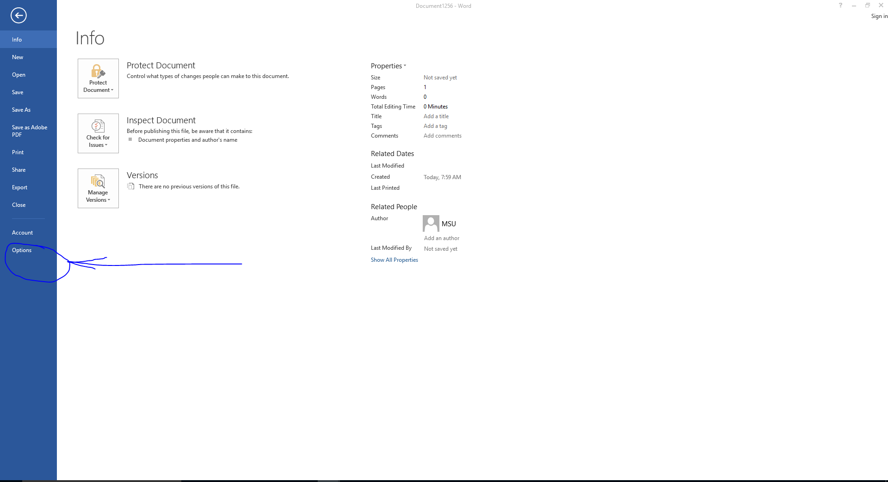

- A new window will open up and you will click on proofing:
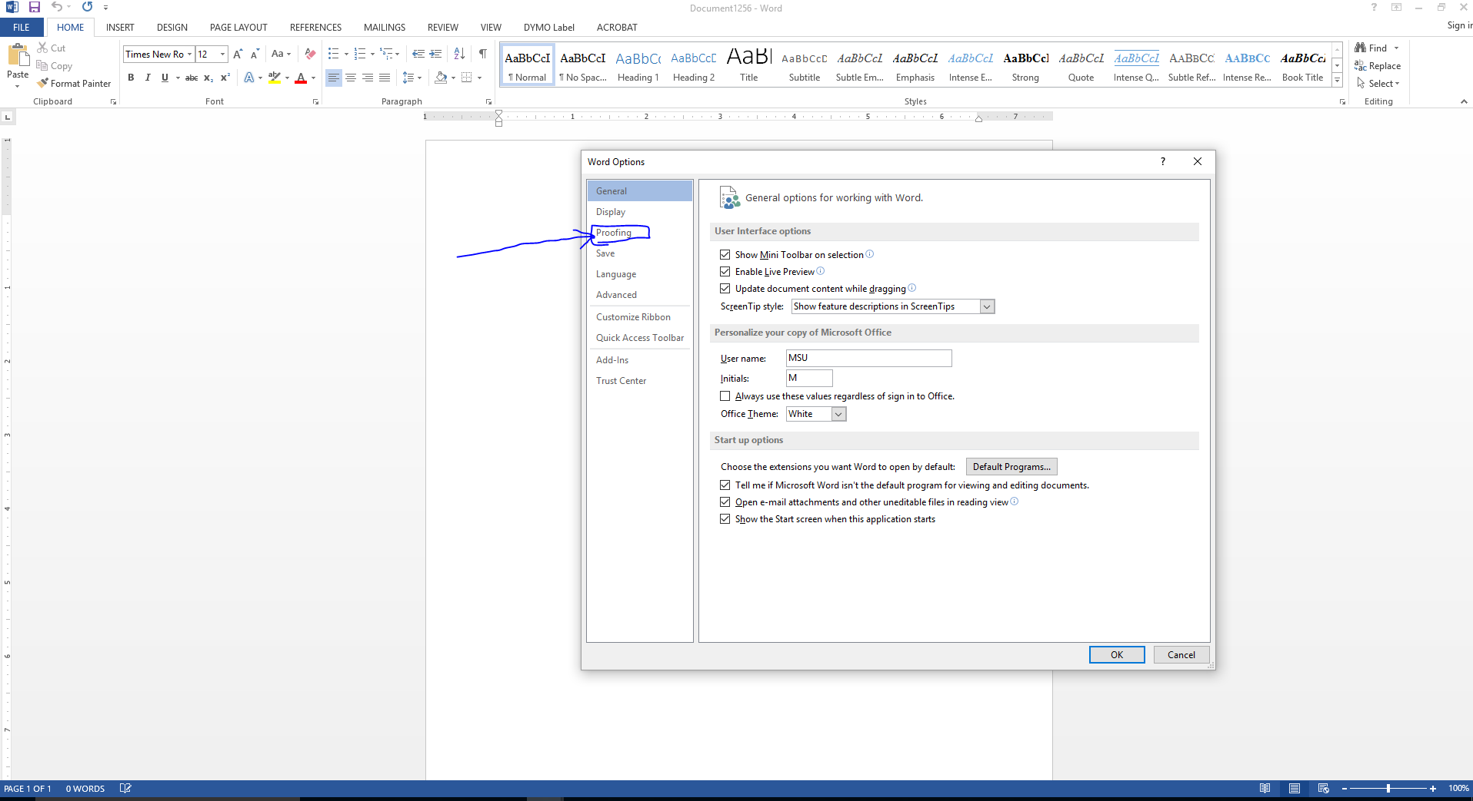

- Once you click on proofing make sure the readability statistics box is check and then press the “ok” button: 