Stage 1: Relevance and Rationale

Task 1: Collection of Artifacts

Collect the following information about the students, classroom, school, and community in which you are assigned. Consider potential sources of information you will need to seek out in order to collect the information required for this stage.

Artifact | Instructions
- Community  Community Mapping | Conduct a geographical search of the surrounding area of the school you have been assigned to by completing the following:  Using a printed map identify churches, businesses, retail stores, abandoned buildings/houses, etc. within .5 mile radius of the school.  Submit two (2) photos that represent positive images from the neighborhood (e.g., parks, new developments, library, etc.)
- School  School Report Card | https://louisianaschools.com/  Type school name under ‘Jump right to your school or center’.  Print the information found on the ‘About our School’ tab.  Click on the ‘Academic Performance’ tab; then click Overall Performance. Print that information.
- Learning Environment Survey  - Teacher Resident completes the Learning Environment Survey  - Mentor Teacher or Administrator completes the Learning Environment Survey  *Submit both | Both the Teacher Resident AND Mentor Teacher/Administrator fully complete the Learning Environment Survey including comments for each indicator (pp. 148-149) from Muhammad, A., & Hollie, S. (2012). The will to lead, the skill to teach: Transforming schools at every level. Solution Tree Press. ISBN 978-1-935542-54-4.  (Appendix A: Survey attached to end of this document.)  *Expectation is that both parties will include comments for each indicator.
- Learning  Environment Overview  Classroom and student features | Define the student population of your assigned classroom according to number of students, age range, gender, resources (equipment, technology, and supplies), and teaching interruptions.  (Appendix B: Chart attached to the end of the document.)  *Expectation is that evidence/examples will be included in chart.
- Student Academic Information  Summative data on the specific content area you will be teaching for this portfolio.  *Include data report | Determine the specific content area to base your unit.  Gather summative data to analyze that aligns with that content.  Data must cover cumulative learning: LEAP 2025, DCA, DIBELS, End of Course Testing, SLT, etc.  Submit a redacted copy of the data, assign a number for each student for labeling purposes throughout the portfolio. (no personal identifiable student information should be shown/submitted).  Using the Student Academic Information chart indicate the number of students with 504’s or IEPs and group the students by ability level and include an explanation for your choices.  (Appendix C: Chart attached to the end of the document.)  *Expectation is that reasoning for each group and explanation of what summative assessment was used will be included in chart.
- Behavioral Observational Notes  Anecdotal notes about student behavior and participation during a lesson.  (LTPGC C1) | Record observed behavior and participation of each student during a lesson being taught (by yourself or the Mentor Teacher). Note any behaviors, positive or negative, that may have impacted the student’s understanding in the content.  Student # should match Student Academic Information section artifact above.  (Appendix D: Chart attached at the end of the document.)  *Expectation is that evidence/examples will be included in chart for EVERY student.
- Student Preferences  Choose an inventory to disseminate to students  *Include inventory and 5-7 student artifacts  (InTASC 1b) | Determine an inventory that you can give students that will allow you to learn about them that affects the content area chosen.  Attach a copy of the inventory.  Attach a chart of the data collected. Use student numbers, not names, that match Task 1, artifact 5.  Attach 5-7 student artifacts as evidence.  (Appendix E: Chart attached at the end of the document.)
Additional Artifact for Score of 4:  Seating Chart | Create a seating chart diagram of the students in your classroom (use numbers to identify them matched with Task 1, artifact 5).  Using 2 pieces of information collected in artifacts 4-7, code your seating chart to designate individual student characteristics (2 descriptors must be identified on diagram).

Appendix A: Learning Environment Survey

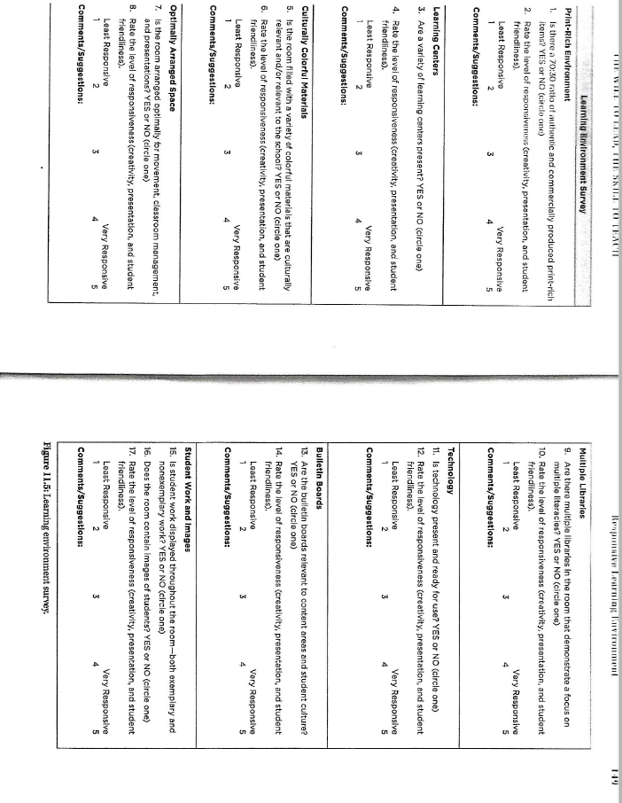

Appendix B: Learning Environment Overview

Number of Students enrolled ____ | Ages in class (range)____________
Gender: # Boys______ # Girls ______

Place an X beside the phrase that describes the resources (equipment, technology, and supplies) available for this class.
Descriptions of categories:
Well-equipped/supplied: Every student has access to technology within the classroom and interactive technology is available to be used for instruction.
Adequately-equipped/supplied: Some students have access to technology within the classroom and interactive technology is available to be used for instruction.
Poorly-equipped/supplied: Students do not have access to technology within the classroom and there is not interactive technology available to be used for instruction.

___well-equipped/supplied ___ adequately equipped/supplied ____ poorly equipped/supplied

Please provide evidence for your choice:

Place an X beside the phrase that describes the number of teaching interruptions.
___few ___some ___many

Provide examples:

Appendix C: Student Academic Information

Indicate the # of students in each category below based on what you’ve observed in the classroom.
_____ ESL _____ # with IEPs or IFSPs _____ # with 504 modification
_____ Gifted _____ # with assistive technology _____ Other

Number your students on the data report received from the teacher. Record the numbers of the students in each category based on data from the Summative Assessment. Provide an explanation as to why you grouped them the way you did.

Low
Student that make up this group: Reason for grouping students:

Low/Medium:
Student that make up this group: Reason for grouping students:

Medium:
Student that make up this group: Reason for grouping students:

Medium/High:
Student that make up this group: Reason for grouping students:

High:
Student that make up this group: Reason for grouping students:

What summative assessment was used to determine number of students for each category?

Appendix D: Behavioral Observational Notes

Below, record observed behavior and participation of each student during a lesson being taught (by yourself or the Mentor Teacher). Note any behaviors, positive or negative, that may have impacted the student’s understanding in the content.

Student # | Observations of student participation or behavior during lesson
1

2

3

4

5

6

7

8

9

10

11

12

13

14

15

16

More space can be added as needed.

Appendix E: Student Preferences

Name of inventory and what it measures:

Findings with categories and number of students (to what is applicable to the content being taught):

Number your students on the data report (do not use their names or any other identifiable information). Record the numbers of the students in each category based on data collected from the inventory. Provide an explanation as to why you group them the way you did.

Group #1
Student that make up this group: Reason for grouping students:

Group #2
Student that make up this group: Reason for grouping students:

Group #3
Student that make up this group: Reason for grouping students:

Group #4
Student that make up this group: Reason for grouping students:

Group #5
Student that make up this group: Reason for grouping students:

